IT-SIMPLERA INSTITUTE

Network Administration Internship Program
WEEK 03 LAB REPORT
Submitted By | Muhammad ismail
Submitted to | Jawad Qayum — Senior Network Administrator
Department | Network Administration
Institute | IT-Simplera Institute
Week | 03
Submission Deadline | 17 July 2026
Tools Used | GNS3

Title:-
Configuration of OSPF Multi-Area, RIP Routing, Static Routes, Floating Static Routes, and Route Redistribution in GNS3
Objectives:-
- To create the given network topology in GNS3.
- To configure IP addresses on routers and PCs.
- To implement OSPF Multi-Area routing.
- To configure RIP Version 1 and RIP Version 2 routing protocols.
- To implement Static Routing between routers.
- To configure Floating Static Routes for backup paths.
- To perform Route Redistribution between OSPF and RIP.
- To verify network connectivity using Ping and Traceroute commands.
- To analyze routing tables and routing protocol operations.
- To ensure successful communication between all LANs in the network.
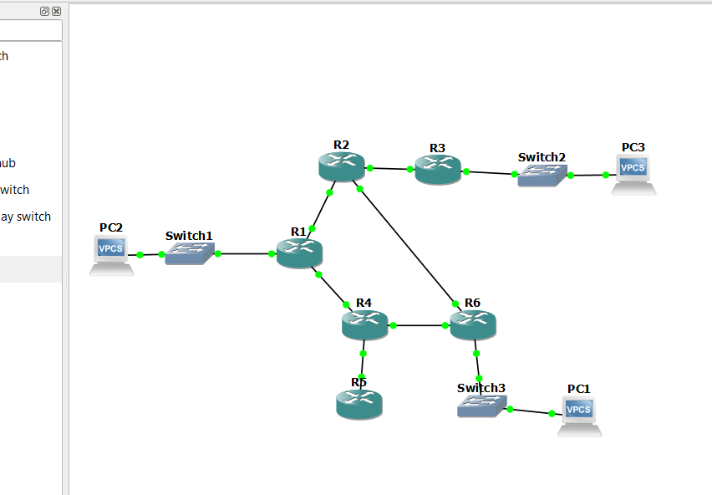
R1 all configuration:-
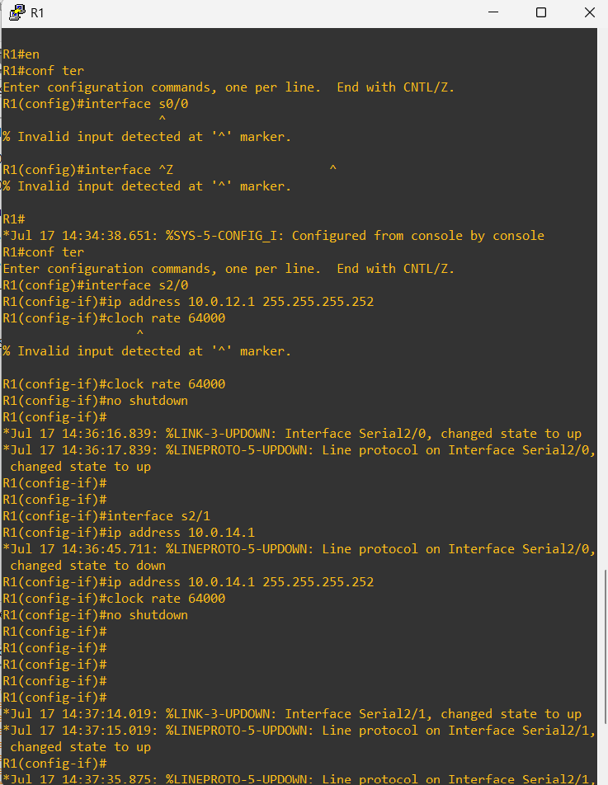
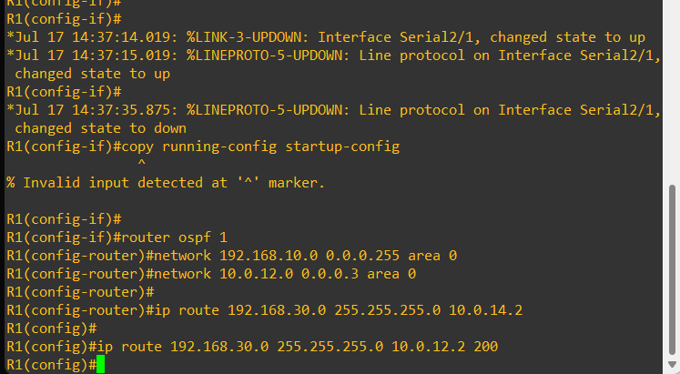
R2 all configuration:-
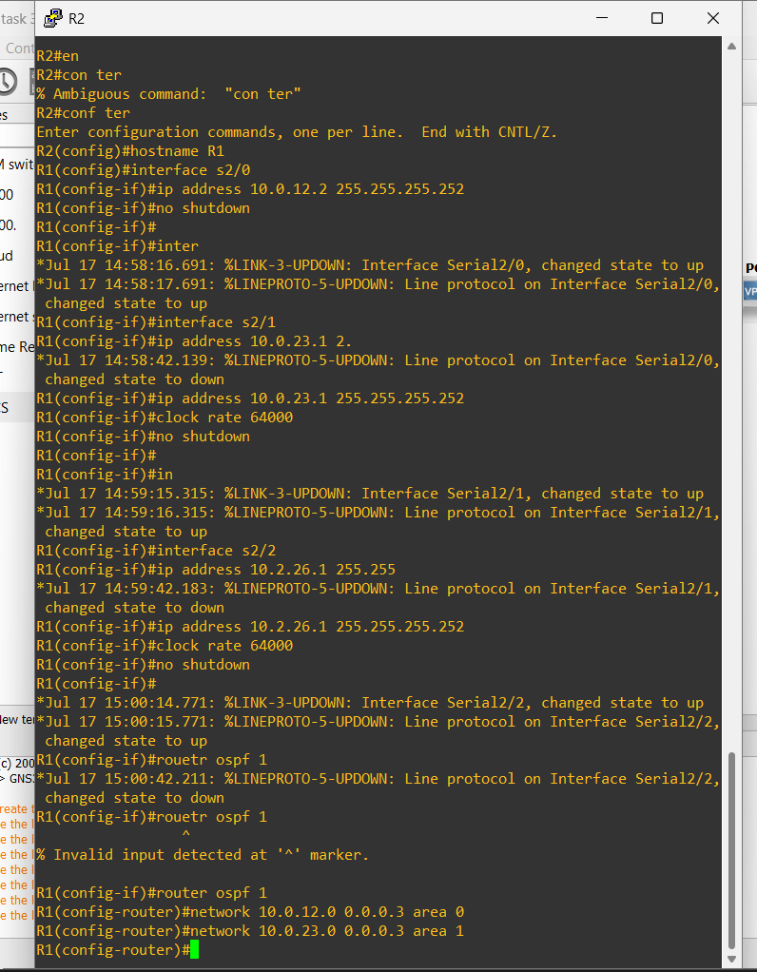
R3 OSPF AND RIP configuration:-
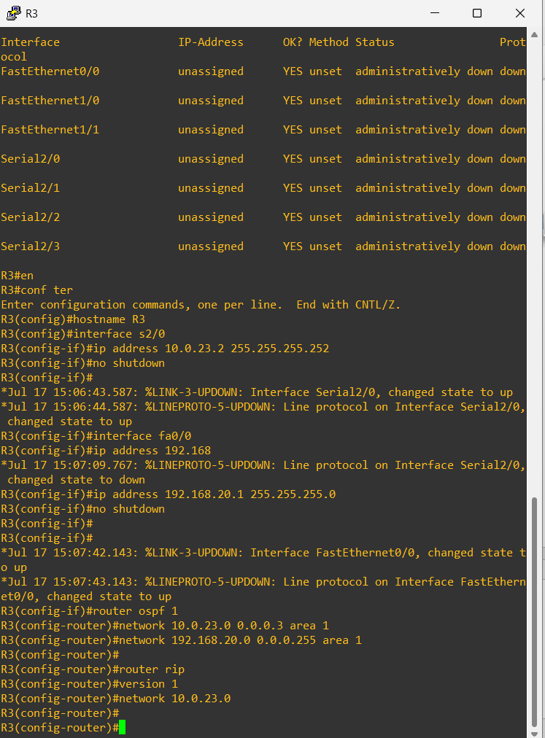
R4 OSPF AND RIP configuration:-
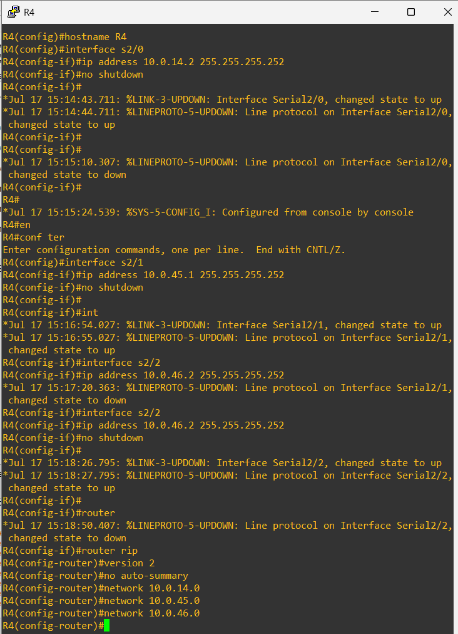
R5 AND RIP configuration:-
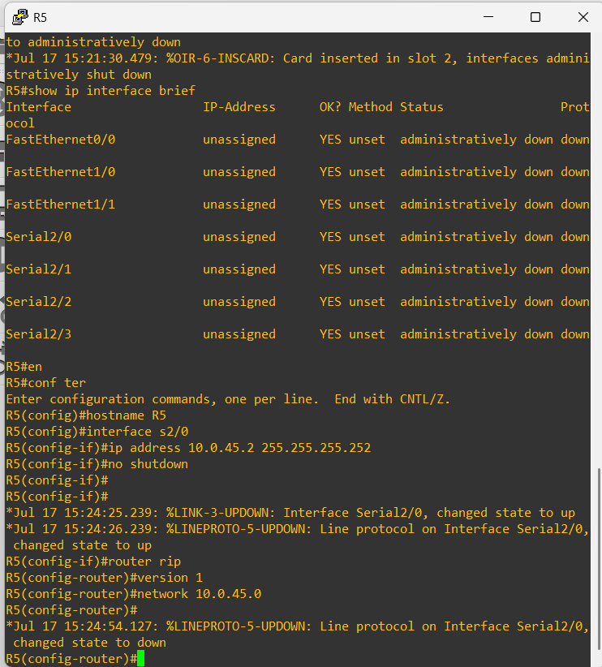

Configuration of R6 and Redistribution:-
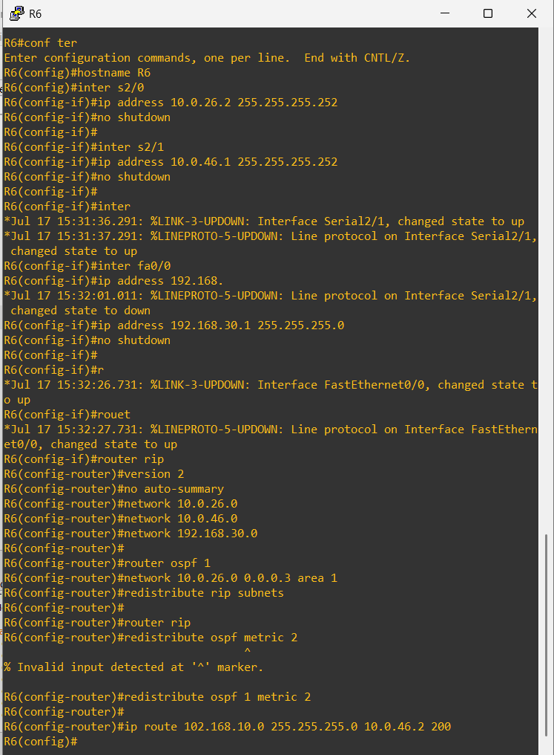
Configure PCs:-
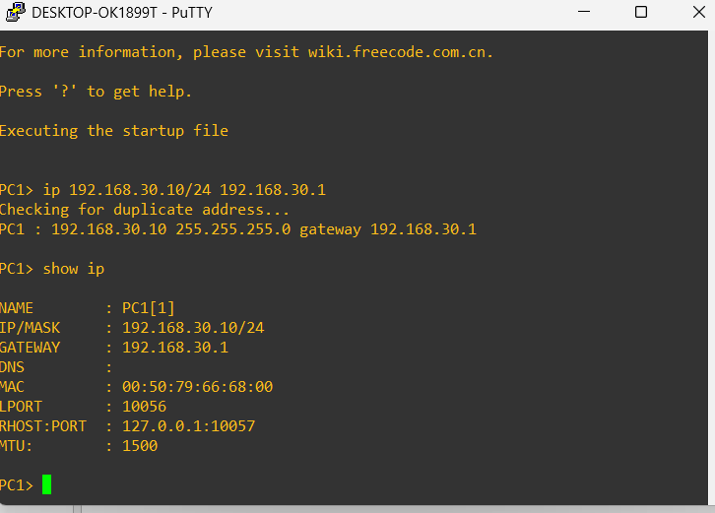
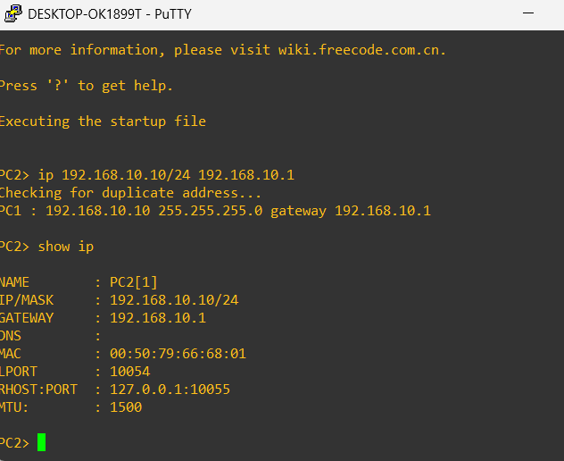
Verification and Testing:-
